WEEK OF:

April 4-8, 2022
Since we all have to practice social distancing and we are all missing our friends and getting bored. Please come out and join your friends in all the activities now being offered online. You choose to join us when it works best for you….
If you have any suggestions on topics to discuss, or things you would like to do, we would love to hear from you!
We will be using ZOOM for all virtual activities.
Hope to see you soon. Stay safe and take care of each other.

April 4-8, 2022
To join our Virtual ZOOM events please click on the link below:
Call or email for Zoom link.
Monday | Tuesday | Wednesday | Thursday | Friday
10am  Home Alone  (Stacy)  11 am  Mystery Tour ...  revisit your important events!  along with some photos from the United Kingdom  (Send your special moments)  (Diane) | 10am  Learn to Draw......  EASTER PUG  (Zelia)  11 am  Math & Literacy  Word scrambles, fill in the blank, literacy & Math, Money, clocks, numbers and more!  All skill levels!  (Diane) | 10 am  Crafts: EASTER HEN  Standing table ornament  Supplies:  Cardboard or card stock, paper towel, 2 egg carton cups, play dough (modelling clay) or similar to weight the ‘hen’ so it stays upright, 2 skewers, white & hot glue, pen, scissors, paint/brushes  Optional: red felt, googly eyes, pipe cleaners  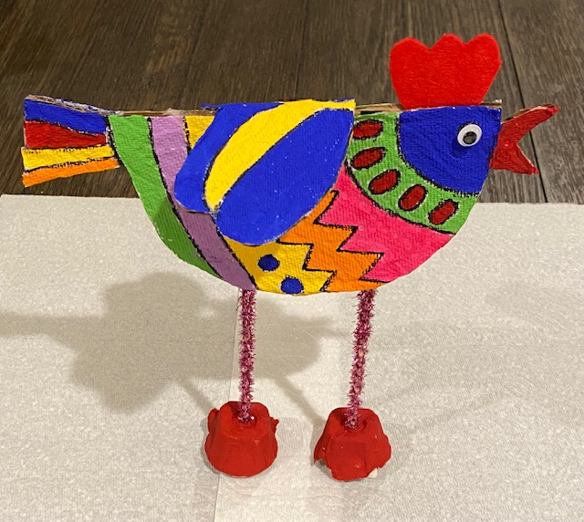  (Diane)  11 am  ASL  (Stacy)  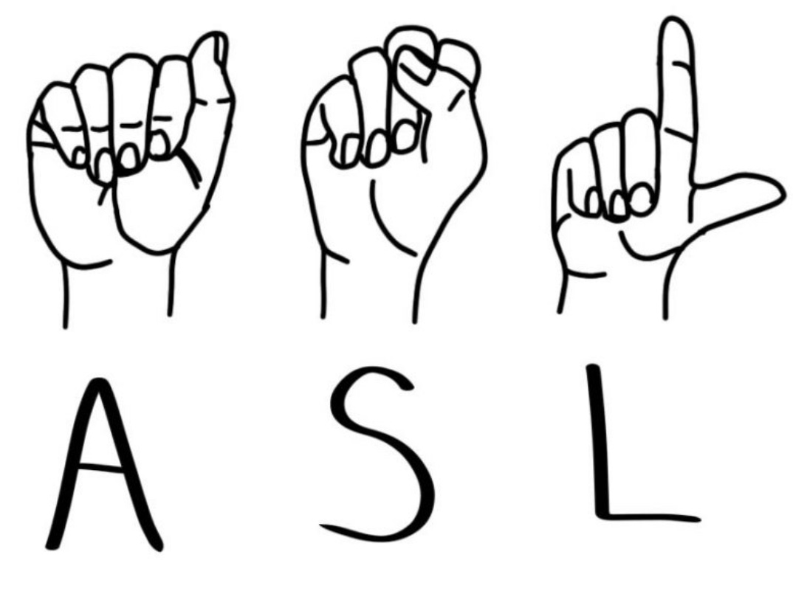 | 10 am  ZUMBA  (Marcia/Zelia)  An invitation has been extended to our friends from other Agencies.... WELCOME!  11 am  Learning for Fun!  and  Relaxation  (Rene) | 10 am  Learn a few words in Portuguese  (Zelia)  11 am  Book Club  Signs of Spring  (Diane)
LUNCH | LUNCH | LUNCH | LUNCH | LUNCH
1 pm  Virtual CHAT – come and  Say ‘Hi” to your friends, what have you been up too?  (Zelia)  7 pm  Friendship  (Samantha)  Meeting ID# 873 1123 3839  Password: friendship | 1 pm  Bingo  Spring has Sprung  (Diane)  Spring Bingo Cards will be used during the month of April and May | 1 pm  Word Games  (Diane) | 1 pm  Basic First Aid  Let’s talk...  What to do in the event of ....  (Diane) | 1 pm  Virtual CHAT – come and  Say ‘Hi” to your friends, what have you been up too?  (Zelia)  Spring Jokes  Q. When do astronauts eat?  A. At ‘launch’ time!  Ha ha ha!  Q. What did the paper say to the pencil?  A. You have a good point!  Q. Why do ‘pancakes’ always win at baseball?  A. Because they have the best ‘batter’!!!  Ha... ha.... ha.... Funny!  Have a great weekend!
Please be advised: Pictures and/or Video recordings may occur during Zoom sessions. If this is a concern for you, please deactivate your camera (so the screen is black) or move outside the camera range.
The DO’S and DON’TS of ZOOM Group Activities
Charging your devices
- Charge your device (phone, tablet, iPad, computer) as much as possible. Video Chat takes a lot of battery power, you may want to keep a charger close while chatting.
- When starting the group please say “Hi” to everyone when the group is starting, then please mute yourself. If you are late arriving – one of the facilitators will let you know when it’s a good time to say “Hi” to everyone.
  - It’s very hard to hear when everyone is unmuted.
  - If you need help or have a question, please raise your hand this will let the host know.
- If the host has asked everyone to mute or has muted you please keep your mute on until asked to unmute as it gets very disruptive and loud to the zoom group.
- If there is a noise in your house i.e., Dog barking, TV playing in the background, your parents talking on the phone…. Please mute yourself.
Volume
- Ensure your volume is on and up. You will need to turn this on, as it is how you will be able to hear others.
Camera
- Ensure your camera is on. You will need to turn it on, if you would like to be seen by others.
  - If you do not want to have your camera on that is ok if you are having a bad hair day or if you need to eat your lunch, it’s ok to have your camera turn off.
Being camera ready for the day / Up, dressed, and ready to go!
- During a zoom call it’s important that we are up and dressed looking camera ready, sitting up and ready to participate in the living room or kitchen or even outside if your WIFI goes that far.
- Sitting or lying-in bed is not appropriate when on a video call as you are expected to present yourself as if you are in an in-person group (fully dressed and ready to go).
Connecting with our friends
- If this is not enough time with your friends or if you want to have a personal conversation our zoom meetings are not the place.
- Please connect with your friends using phone, facetime, messenger, Skype, WhatsApp.
PRIVATE information: What is private?
- Giving your address and phone number out during a zoom meeting.
- Talking about Dating.
Being respectful - What is not appropriate to talk about or say on our ZOOM group;
- I am your friend or not your friend
- I don’t like you
- I want to punch you
- Giving someone the finger
- Swearing
- I am going call you tonight
Some of this are hurtful to others or if they are not including so its best just not to talk about it during the meeting.
Going to the washroom
- Remember do not take your iPad/phone to the washroom as this is private room and your Zoom meeting does not need to go with you - Leaving your device and coming back when you are done is perfectly ok.
- Ohhh… wait don’t forget to wash your hands really well!

